K8S 监控解决方案

1. K8s 环境

Server: 1.17

Client: 1.15

1. 方案

heapster+influxdb+grafana

1. 部署方法

wget https://github.com/kubernetes/heapster/archive/v1.5.2.zip

unzip v1.5.2.zip

cd heapster-1.5.2/deploy/kube-config/influxdb

grafana.yaml

apiVersion: apps/v1

kind: Deployment

metadata:

name: monitoring-grafana

namespace: kube-system

spec:

replicas: 1

selector:

matchLabels:

k8s-app: grafana

template:

metadata:

labels:

task: monitoring

k8s-app: grafana

spec:

containers:

- name: grafana

image: gcr.io/google_containers/heapster-grafana-amd64:v4.4.3

ports:

- containerPort: 3000

protocol: TCP

volumeMounts:

- mountPath: /etc/ssl/certs

name: ca-certificates

readOnly: true

- mountPath: /var

name: grafana-storage

env:

- name: INFLUXDB_HOST

value: monitoring-influxdb

- name: GF_SERVER_HTTP_PORT

value: "3000"

# The following env variables are required to make Grafana accessible via

# the kubernetes api-server proxy. On production clusters, we recommend

# removing these env variables, setup auth for grafana, and expose the grafana

# service using a LoadBalancer or a public IP.

- name: GF_AUTH_BASIC_ENABLED

value: "false"

- name: GF_AUTH_ANONYMOUS_ENABLED

value: "true"

- name: GF_AUTH_ANONYMOUS_ORG_ROLE

value: Admin

- name: GF_SERVER_ROOT_URL

# If you're only using the API Server proxy, set this value instead:

# value: /api/v1/namespaces/kube-system/services/monitoring-grafana/proxy

value: /

volumes:

- name: ca-certificates

hostPath:

path: /etc/ssl/certs

- name: grafana-storage

emptyDir: {}

---

apiVersion: v1

kind: Service

metadata:

labels:

# For use as a Cluster add-on (https://github.com/kubernetes/kubernetes/tree/master/cluster/addons)

# If you are NOT using this as an addon, you should comment out this line.

kubernetes.io/cluster-service: 'true'

kubernetes.io/name: monitoring-grafana

name: monitoring-grafana

namespace: kube-system

spec:

# In a production setup, we recommend accessing Grafana through an external Loadbalancer

# or through a public IP.

# type: LoadBalancer

# You could also use NodePort to expose the service at a randomly-generated port

# type: NodePort

type: NodePort

ports:

- port: 80

targetPort: 3000

selector:

k8s-app: grafana

heapster.yaml

apiVersion: v1

kind: ServiceAccount

metadata:

name: heapster

namespace: kube-system

---

apiVersion: apps/v1

kind: Deployment

metadata:

name: heapster

namespace: kube-system

spec:

replicas: 1

selector:

matchLabels:

k8s-app: heapster

template:

metadata:

labels:

task: monitoring

k8s-app: heapster

spec:

serviceAccountName: heapster

containers:

- name: heapster

image: gcr.io/google_containers/heapster-amd64:v1.5.2

imagePullPolicy: IfNotPresent

command:

- /heapster

- --source=kubernetes:https://kubernetes.default?kubeletHttps=true&kubeletPort=10250&insecure=true

- --sink=influxdb:http://monitoring-influxdb.kube-system.svc:8086

---

apiVersion: v1

kind: Service

metadata:

labels:

task: monitoring

# For use as a Cluster add-on (https://github.com/kubernetes/kubernetes/tree/master/cluster/addons)

# If you are NOT using this as an addon, you should comment out this line.

kubernetes.io/cluster-service: 'true'

kubernetes.io/name: Heapster

name: heapster

namespace: kube-system

spec:

ports:

- port: 80

targetPort: 8082

type: NodePort

selector:

k8s-app: heapster

*创建clusterrolebinding

kubectl create clusterrolebinding heapster --clusterrole=cluster-admin --serviceaccount=kube-system:heapster

influxdb.yaml

apiVersion: apps/v1

kind: Deployment

metadata:

name: monitoring-influxdb

namespace: kube-system

spec:

replicas: 1

selector:

matchLabels:

k8s-app: influxdb

template:

metadata:

labels:

task: monitoring

k8s-app: influxdb

spec:

containers:

- name: influxdb

image: gcr.io/google_containers/heapster-influxdb-amd64:v1.3.3

volumeMounts:

- mountPath: /data

name: influxdb-storage

volumes:

- name: influxdb-storage

emptyDir: {}

---

apiVersion: v1

kind: Service

metadata:

labels:

task: monitoring

# For use as a Cluster add-on (https://github.com/kubernetes/kubernetes/tree/master/cluster/addons)

# If you are NOT using this as an addon, you should comment out this line.

kubernetes.io/cluster-service: 'true'

kubernetes.io/name: monitoring-influxdb

name: monitoring-influxdb

namespace: kube-system

spec:

type: NodePort

ports:

- port: 8086

targetPort: 8086

selector:

k8s-app: influxdb

部署效果：

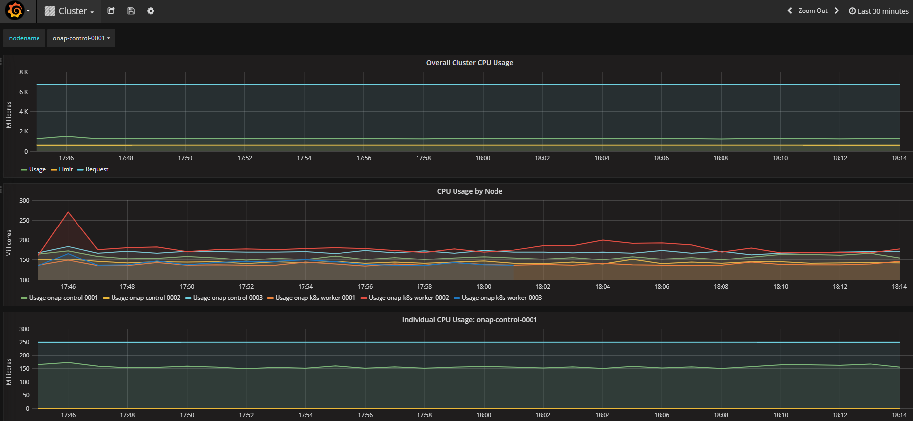

尚未解决问题：

Grafana 账号管理问题

注： Heapster 已经被K8S遗弃，目前使用的是metrics-server

部署如下：

<https://github.com/kubernetes-sigs/metrics-server>

kubectl apply -f https://github.com/kubernetes-sigs/metrics-server/releases/latest/download/components.yaml

Bitnami Thanos 版本

<https://docs.bitnami.com/kubernetes/infrastructure/thanos/>

https://bitnami.com/stack/grafana/helm